**K R Harrini Shree**

**“HarriniGpt” - An AI Based Discord Bot**

1

3/21/2024 **Annual Review**

PROJECT TITLE

**“HarriniGpt” - An AI Based Discord Bot**

2

3/21/2024 **Annual Review**



3/21/2024 **Annual Review**

# AGENDA

The overall goal of this project is to develop a Discord bot that improves communication within a Discord server by utilising OpenAI's artificial intelligence (AI) capabilities. Based on the messages it receives, this bot can have discussions, respond to inquiries, and offer help. The model used here is GPT-3.5 model provided my OpenAI.

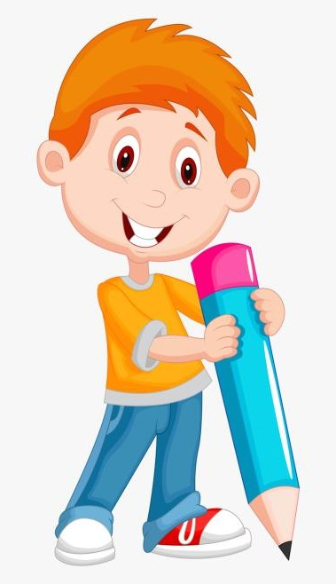

**BREAKDOWN OF THE PROJECT'S AGENDA:**

1)Discord Bot 2) OpenAI Integration 3) Debugging

Discord Bot: The project's goal is to develop a bot that can

function inside a Discord server. It uses the Python discord

library to establish a connection to Discord and communicates

with the Discord API to send and receive messages.  
  
OpenAI Integration: To produce message answers, the bot interfaces with the OpenAI API. The message content is sent as a prompt to the OpenAI API by the bot whenever it is mentioned in a message. The GPT-3.5 model is used by the API to construct a response, which is then sent back to the Discord channel where the message was received by the bot.

Debugging: Print statements are included in the code to aid with debugging. These print statements support the OpenAI API's monitoring of incoming messages, mentions, and responses. They shed light on the behaviour of the bot and assist in locating any problems that may arise throughout development.

3

PROBLEM STATEMENT

Create a Discord bot to improve communication inside

a Discord server by leveraging AI capabilities. It should

be feasible for the bot to produce thoughtful replies to

messages that people in the server send. The principal

objective is to develop a bot that converses with users

in a natural and relevant way, offering support, and



responding to queries, and participating in discussions.

PROJECT OVERVIEW

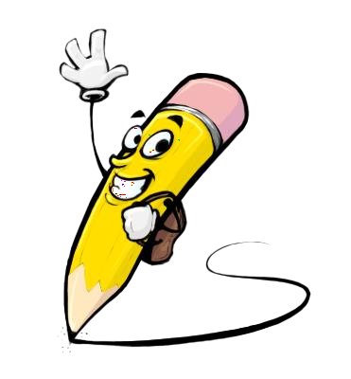

Project Synopsis:  
Title: OpenAI-Integrated Discord Bot  
  
  
The project's goal is to create a Discord bot that can

improve communication on Discord servers by using

OpenAI's natural language processing powers. In light

of the context of the conversation, the bot will be able

to intelligently reply to messages provided by users,

participate in discussions, respond to inquiries,

and offer assistance.

Features:

1. Discord Integration: By utilising the Discord API to connect to Discord servers, the bot will be able to send and receive messages instantly.
2. OpenAI Integration: By integrating with OpenAI's API, the bot will be able to respond to user messages by using sophisticated natural language processing models, such GPT-3.5. The OpenAI API will receive user messages from the bot as prompts, and it will reply to users with the responses it generates.
3. Mention Detection: The bot is going to be configured to recognise when it appears in messages on Discord servers. It will process the message and, if required, produce a response after detecting it.
4. Natural Language Understanding: To comprehend the context and meaning of user messages, the bot will make use of natural language processing algorithms. It will be able to produce thoughtful and contextually appropriate responses thanks to this understanding.
5. User Engagement: The bot's goal is to have meaningful and organic discussions with users. It will respond with useful and instructive information, improving the user experience on Discord servers.
6. Deployment: The bot will be put online and accessible to users around-the-clock by being placed on a hosting platform. Platforms like Replit, Heroku, or dedicated server hosting are examples of deployment choices.

 5

WHO ARE THE END USERS?

1) Members of Discord communities or servers : They are the places where the bot is installed make up the majority of the bot's end users. By messaging, enquiring, requesting help, or taking part in discussions, these users interact with the bot.

2) Server Administrators and Moderators: In addition to performing administrative duties and managing server settings, server administrators and moderators can also communicate with the bot to access features specifically intended for moderation.

3)Content Creators and Streamers: As part of their community engagement plan, content creators and streamers who operate Discord servers may use the bot to communicate with their audience, respond to inquiries, or add some extra fun to live streams or gaming sessions.

4)Community Managers and Support Teams: Community managers and support teams within organizations or communities may leverage the bot to provide support, answer frequently asked questions, or disseminate important information to members of the Discord server.

5)General Public: Depending on the accessibility and visibility of the Discord server where the bot is deployed, members of the general public who join the server may also interact with the bot, especially if the server is open to the public or focuses on topics of broader interest.

 6

3/21/2024 **Annual Review**

YOUR SOLUTION AND ITS VALUE PROPOSITION

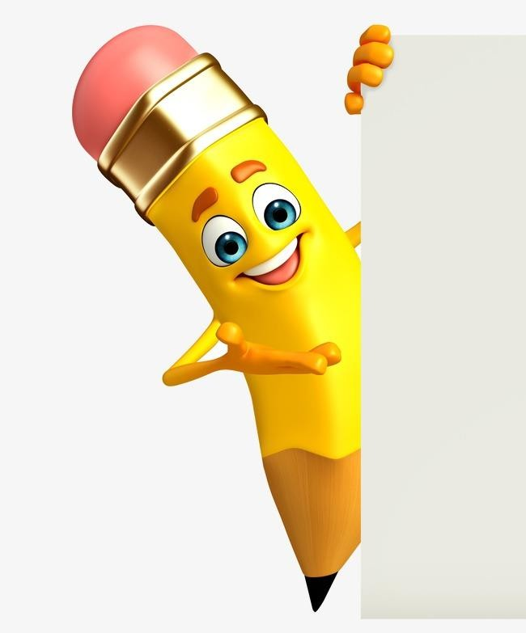

3/21/2024 **Annual Review**

By improving the user experience, offering on-demand support,

encouraging interaction and entertainment, and increasing the

time and resource efficiency within Discord servers, the

Discord bot with OpenAI integration is a valuable offering. It

Enhances Discord groups with intelligence and interaction,

making them more lively and productive as virtual communities.   
  
Mechanisms to solution:

Intelligent Conversational Interface: The bot functions as an

intelligent conversational interface on Discord servers,

interpreting messages from users, providing responses that are

appropriate for the context, and having natural language

discussions with them. Discord communities can now

communicate in a more dynamic and interactive way thanks to this.  
  
Improved User Experience: The bot improves the user experience on Discord servers by utilising OpenAI's natural language processing models. With the bot, users may engage in more meaningful conversations or connect in a more conversational and natural way, gaining helpful and relevant answers to their questions.  
  
On-Demand Assistance: Depending on the topic at hand and the context of the conversation, the bot responds to inquiries, offers information, or gives advice to users inside Discord servers. This can lessen the amount of work that support teams and server administrators have to do.

Engagement and fun: The bot enhances the overall sense of community by bringing fun and engagement to Discord servers. For entertainment reasons, users can play trivia games, have simulated chats, or communicate with the bot.

Time and Resource Efficiency: The bot helps server administrators and support teams save time and resources by automating responses and offering on-demand assistance. It can independently manage routine requests and jobs, freeing up human resources to concentrate on higher-priority or more complicated work.  
  
  
Community Building: By promoting interactions and dialogues among users, the bot helps Discord servers foster a sense of community. It gives users the chance to interact with one another, exchange knowledge, and strengthen their sense of community.

7

THE WOW IN YOUR SOLUTION

The project's solution's "wow" element is its ability

to smoothly incorporate OpenAI's cutting-edge natural

language processing powers into the Discord platform,



resulting in a genuinely intelligent and engaging bot. All

things considered, the project's solution's "wow" element

is its capacity to harness cutting-edge technology to

produce a genuinely intelligent, dynamic, and captivating

bot that boosts user satisfaction, encourages community

involvement, and increases server efficiency in Discord.

It changes the way users engage with the platform,

creating a long-lasting impact and encouraging more

involvement from the server community.

8

3/21/2024 **Annual Review**

# MODELLING

# A project is usually modeled according to the software development life cycle, which includes several stages from initial design to implementation and maintenance. My project can be modeled as follows:

# 1.Requirements Planning and Gathering : Determine project goals, objectives and target audience. Gather requirements by understanding the needs of Discord server users and administrators. Define the scope of the project, including key functions of robots and functionality.

# 2. Design: Design the bot's architecture, including how it interacts with the Discord API and OpenAI API. Define data flow, message handling logic, and integration points. Create wireframes or templates from the bot interface (if possible).

# 3. Development: Implement bot functionality according to defined requirements and design. Set up communication with Discord API to send and receive messages. Integrate with OpenAI API to generate responses based on user messages. Implement features like mention detection, natural language understanding and error handling. Write unit tests to ensure bot behavior is reliable and correct.

# 4. Testing: Perform testing to ensure the bot behaves as expected in different scenarios. Test the bot's responses to different types of user messages, including questions, commands, and random chat. Run integration testing to ensure smooth interactions With Discord and OpenAI APIs. Identify and fix bugs and issues found during testing.

# 5. Documentation: Document the features, functionality, and usage instructions for the bot. Provide instructions for installing and configuring the bot on the Discord servers. Document any required dependencies, environment variables, or configuration settings for deployment.

# 6.Deployment: Deploy the bot on a hosting platform like Replit, Heroku or a dedicated server. Set permissions and settings to ensure the bot runs safely on Discord servers. Test the deployed bot in a live environment to ensure it is up and running.

# 7. Maintenance and Updates: Monitor the bot's performance and fix any issues or bugs. Provide ongoing support to users and administrators interacting with the bot.- Deploy updates and improvements based on feedback from user’s suggestions or changes to the Discord or OpenAI APIs. Regularly review and optimize the robot's code base to ensure efficiency and reliability.

3/21/2024 **Annual Review**

# RESULTS

# The project's outcomes show how a Discord bot with OpenAI integration can be implemented successfully, fulfilling its goals of improving user support and assistance, enhancing interactions within Discord server communities, and encouraging engagement and community building in a dynamic and engaging setting.

Demo Link

 10

3/21/2024 **Annual Review**